Maidenhead Rugby Football Club

Welcome Pack & Club Information

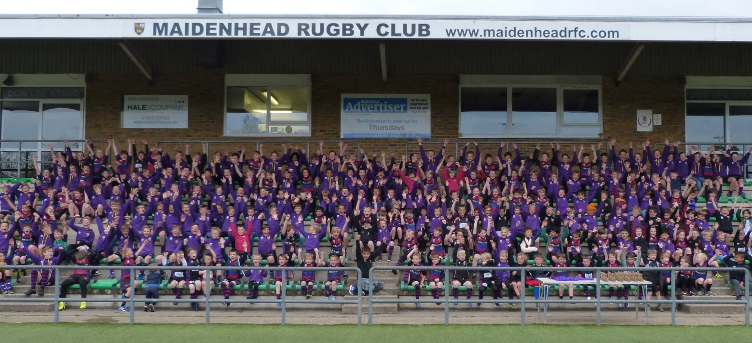



Table of Contents

Welcome 3
Overview 4
Youth rugby 4
Training and playing 5
Training and Playing on the 3G Pitch 5
Maidenhead Kit & Shirts 5
Coaching 6
Braywick Park Pitch Layout 6
Braywick Car Parking 6
Membership 7
Membership Options 7
Memberships & How to Pay Them 8
Things you might want to know in the future 9
Club Communications 9
Club Opening Times 9
MRFC Club AGM 9
Mini’s/Youth End of Season awards 9
Mini’s Christmas Party 9
Youth Welcome back to Rugby event 10
Social Media 10
Opportunities for volunteering 10
Social Events 10
Opportunities for sponsorship 10
Useful websites/reference documents 10
Safeguarding & policies 11
Coaches (and other volunteers) 11
A Duty of Care – Comprehensive training for all head coaches and managers. 11
Parents 11
First Aid 12
Discipline 12

Welcome

Thank you for your interest in our rugby club. We have been a part of the Maidenhead community since 1922 and the club has a clear aim to remain a community club that maintains the core values of rugby throughout our 12 age groups, 2 senior teams and approximately 1500 members including players.
We have a one club philosophy and whether you are a youth member or a senior member, you are fully embraced within all aspects of the club.
We are proud to be a RFU Accredited Club. The Club Accreditation Programme is based upon the six Key Drivers identified as crucial to a strong club:

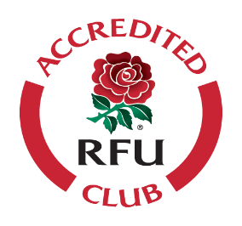
- Retaining & Developing Players
- Recruiting New Players
- Recruiting & Retaining High Quality Coaches, Volunteers & Referees
- Effective & Efficient Facilities
- Effective & Efficient Management and Governance
- Integration with the Local Community

Our club philosophy is to provide and enjoyable environment within which all our members can enjoy the rugby values, both on and off the pitch that the game we love has to offer.
This handbook sets out all the information you need to know when joining our rugby club - as a player, parent or volunteer. This document acts as a starting point but should not replace speaking to your Age Group Manager or another Club Official when you need more information.
All relevant information and contact numbers can be found on the club website maidenheadrfc.com or via your Age Group Manager.
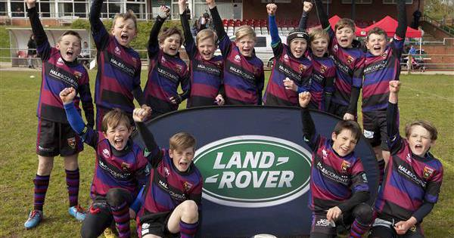

Overview

At Maidenhead, we cater for players of all abilities and interest in the game of rugby.
- 1st XV – play in Regional 1 South Central
- 2nd XV - play in BBO Counties 2
- Our Women’s team (newly launched)
- Vets play on a Friday night just for fun
- Maidenhead Colts (U17s and U18s) – play in Oxfordshire, Berks and Bucks league
- Maidenhead Mohawks Touch Team play in National Touch Series, they train Tuesday evenings 19:30-21:00
- Maidenhead Walking rugby – Wednesday 11am – 12pm and Thursdays 9 – 10pm

Youth rugby
U6 through to U18 including all girls’ squads. Please note that parents/guardians must be present at all training and games/festivals. If you are unavailable, you need to appoint a guardian and let the Age Group Manager know who will be responsible for your child.
The only essential kit that players need are gum shield (U9s onwards) and studded boots (most play is on grass).
Subject to the extra conditions specified for Age Grade players by RFU Regulation 15.10, players are permitted to wear specifically designed sports goggles in all forms of contact rugby where the following conditions are satisfied:
- the sports goggles must be dispensed by a General Optical Council (“GOC”) registered dispensing optician or an optometrist registered with the GOC; and
- the player must have written confirmation from the registered dispensing optician or optometrist that:
  - the goggles are required to correct the vision of the player or are required to protect the player’s eyes due to a medical or optical condition, to enable the playing of rugby union; and
  - the goggles do not substantially restrict any normal field of vision and are suitable for use in evasion contact sports; and
  - the goggles do not constitute a physical danger to the player or other players; and
  - the player is not capable of wearing contact lenses and why this is the case.
Hearing aids are not specifically set out as banned items of equipment. However, they must comply with the requirements of World Rugby World Rugby’s Regulation 12 as set out in Law 4.
Where possible we recommend that hearing aids are removed prior to playing or taking part in any contact activity; but we understand that this may not always be practical.
The decision on whether a hearing aid can be worn for rugby activity (including contact) will depend on the specification of the hearing device. For example, a moulded, modern-day version is more likely to comply with the WR Regulation 12 requirements and unlikely to present any issues. It may, therefore, be appropriate for a moulded hearing aid to be worn, although we’d suggest a head guard/scrum cap is also worn.
Players should not wear any jewellery during training/games that includes earrings.

Training and playing
- Colts/Seniors training - Tuesday and Thursday evenings (7.30pm – 9.00pm)
- Women’s Training - Tuesday and Thursday evenings (7.30pm – 9.00pm)
- Youth training – Mid week evenings (specific to each age group typically 6 – 7pm) and Sunday mornings (training or games) 10.00 – 12.00

Key Dates
- 1st Sunday/weekend in September - Season Kick Off
- End of Sept - Registration deadline
- Season closes – End of April

Training and Playing on the 3G Pitch
If you are playing or training on the 3G pitch, please note: No flat soled shoes at any time on the 3G. This includes all managers, coaches, first aiders, spectators, match officials and also all members of the opposition.
Please make sure opposition are aware of this prior to any games.
- Allowed footwear - Moulded-Studded Boots, Metal-Studded Boots
- Banned footwear - Blades, Flat soled shoes (e.g. shoes/trainers), Astro-Turf Boots

Maidenhead Kit & Shirts
There are broadly 3 options for getting MRFC kit and apparel.
- If you want/need to buy new kit, please head to Hawkinsport our kit supplier (based in Bourne End). The have a large shop but also an online website where you can get home delivery
- The club run 2 Preloved kit sales each season – typically early September and early January – where you can pick up a bargain – your AGM will notify you of dates.
- And we also maintain a facebook Group for parents to post and swap/buy/exchange kit themselves. Preloved kit FB group available - MRFC Preloved Kit Group | Facebook

Please pass any Maids kit donations onto your Age Group Manager who will add them to the Pre-Loved kit sale.

Coaching
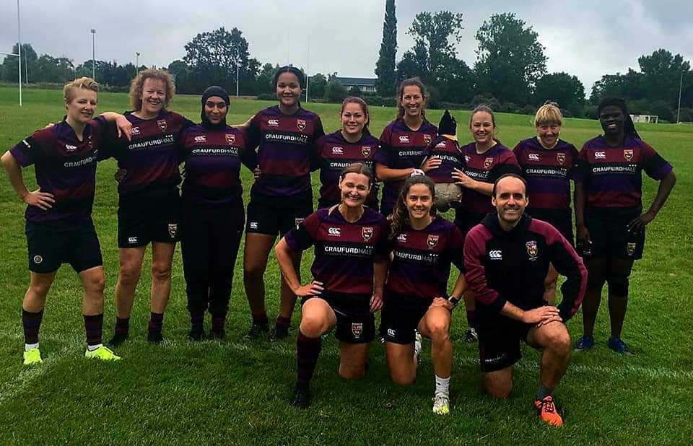
The more parents and friends that get involved the greater the ratio of coaches to players.
If you are interested in helping out, please don’t worry if you don’t know much about rugby, you will be guided by the more experienced coaches and shown what to do. There is also lots of free (& paid) online learning material and courses that will help aswell.
In the early days it’s all about giving encouragement to the players! If you are interested in developing your skills to become formally recognised as a rugby coach then the club will certainly invest in you.
The Youth Section currently boasts 69 Level One coaches, 12 of which have achieved their Level Two qualification, which is standard required to coach a senior side. During the forthcoming season the club expect to add a further 15 Level One and 5 Level Two coaches. All qualifications of this nature are fully funded by the club or through bursary awards.
We are fortunate to have a Coaching co-ordination team headed up by our Director of Rugby who manage and run our Coaching Accreditation Programme and supports all age groups with regard to coaching advice and support.
All coaches are welcome to participate in the Coaching Accreditation Programme. All new coaches need to have an active DBS in place before they can start coaching.

Braywick Park Pitch Layout

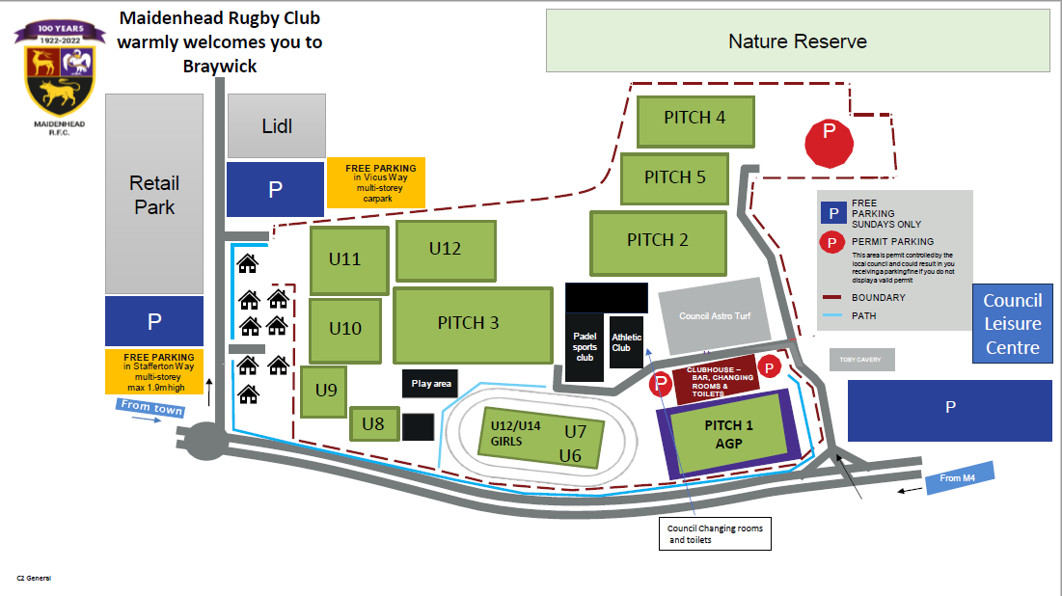

Braywick Car Parking
A parking permit is required for the car parks next to the Rugby Club. Parking without a permit in those areas will receive a RBWM parking ticket.
Full Members of MRFC, as per the table in the Membership Options section will receive their parking permits with their membership cards following receipt of this year’s membership form and subs payment.

Membership

Firstly, all age groups offer a 2 week “taster” / trial at no cost – after that, hopefully you/your player will know if they want to join the club or not. Hopefully they do.
All members must be registered on the RFU Game Management System. Speak to your age group manager for full details
Decide on which membership best suits your situation from the options below
All memberships for existing members should be paid by the end of September at the latest although prior to pre-season is preferable.
Memberships for the whole season are charged at 100%. Any new members joining January onwards are charged 50%. GMS can be updated to reflect the 50% discount – your AGM will organise this for you.
Membership cards & parking permits will come through via your AGM once confirmed as eligible & a fully paid member

Membership Options
Full details of each membership package can be found on the club website
Maidenhead Rugby Club » Memberships
Your Age Group manager will also share with you a ‘How to affiliate players and also How to pay membership documents’
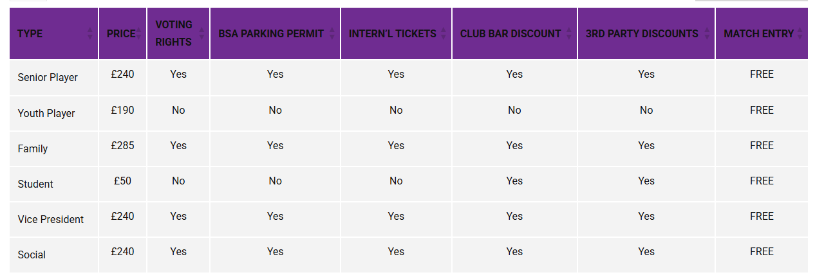
Current 2025 – 2026 Season Membership Options

Memberships & How to Pay Them
A separate guide & instructions sheet is available to share with you so that you have details & instructions to hand when accessing the GMS system to pay memberships.
Registering your details;
- Log on to GMS - https://gms.rfu.com/GMS/Account/Login
- Ensure that you complete all elements of your personal info including clicking on Register Player button if a playing member. This must be done for all children.
- YOUR CHILD MUST BE REGISTERED TO THE CLUB BEFORE ATTEMPTING TO PURCASE MEMBERSHIP
- Make sure that all of your children/partners are linked to you via the relationship tab especially if you plan to buy a family membership
- Please refer to the guide shared by your AGM and/or on the club website – link below – on how to register your player/s and buy the membership

Maidenhead Rugby Club » Memberships

All players planning to train/play in the new season must be registered against the Club. Click on the players name and then registration section – complete/update that section and submit.
If anyone needs GMS support – please go to the Support Section of GMS which is on the log in page or contact your AGM.

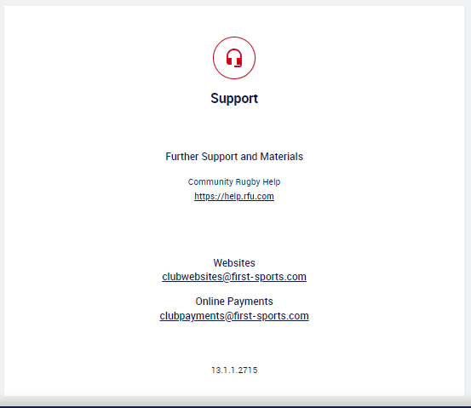

Things you might want to know in the future

Club Communications
Communications from the Club to you as parents & guardians are delivered in the following ways. It is important to ensure you provide your details in GMS or to your AGM to be added to these communication channels.

- Emails – the club provides important, club wide updates via its email membership list (emails taken from the GMS system).
- Availability/fixtures Apps – many of the age groups utilise readily available apps such as Spond. For instance, Spond allows your AGM to post fixtures and events for your age group. You can confirm your childs availability and in the case of paying for minis tournament entry fees, pay directly via Spond. Talk to your AGM to ensure you are added to the app they use.
- Whatsapp – many of the age groups use Whatsapp as a more informal way to notify and remind parents of notices of interest, events or fixtures. Speak to your AGM to ensure you are added to the group whatsapp chat.

Club Opening Times
Don’t forget that this is your club and all facilities are open to all members, not just on Sundays. It is a great place to socialise after training and matches, get to know your age group and also other members of the club.
Please note all opening times are subject to change
  - Saturdays – during the season from 11.00am through to late
  - Sundays – the club is open for breakfast and food from 9.30am and the bar opens at 11.00am
  - Monday - closed unless privately booked
  - Tuesday – 6.00pm till 10.00pm
  - Wednesday - closed unless privately booked
  - Thursday – 6.00pm til 10.00pm
  - Friday – closed unless privately booked during the season:
  - Closed season – see social media for details

MRFC Club AGM
Don’t forget, that as a member, it is your club and your input is highly valued. When the date is announced (typically in May), we encourage members to attend the AGM so that you can see how the club is run and be involved in important elections and decision making processes.

Mini’s End of Season awards
This event is organised by the Head of Mini’s and Mini’s AGMs typically in April. Medals/Season reward provided by the club for all present players at the awards. Honours caps awarded to all players that have been continuously present at the club from U7 to U12. The Junior Age Groups organise their own individual end of season awards event.

Mini’s Christmas Party
There is also a Christmas party typically on the last Sunday of training in December for all the mini age groups – full details will be made available in the run up to Christmas via your Age Group Manager.

club Welcome back to Rugby event
This is organised by the Club at the start of the new season. Held in the evening typically on a Friday. Full details provided in the run up to the new season.

Social Media
Keep abreast of what is happening at the club through the club social media accounts:

Facebook – maidsrfc Instagram – maidenheadrfc Twitter – maidsrfc

Opportunities for volunteering
Your children will want you to watch them and to reinforce their confidence, especially early on. Once you feel they have given you permission to do anything else, we would love if you can help out, even if only here and there. If you would like to find out more, please contact our Club Volunteer co-ordinator Kate Swinn.

Social Events
The Club organise the odd social evening for parents to get together without muddy offspring and also will keep you informed of broader MRFC events like the Children’s Christmas Party and our festival weekend. We organise outings to several professional matches, and other things that catch our fancy.

Opportunities for sponsorship
With such a rich and diverse membership base and weekly links with other rugby clubs, Maidenhead RFC is always interested in discussing great commercial opportunities available around sponsorship. In order to ensure fairness and a whole club approach to sponsorship these discussions are best done through and with the committee.
If you own or work for a company who might be interested in developing a sponsoring relationship with the club, please contact your age group manager in the first instance.

Useful websites/reference documents

- Rugby Football Union www.rfu.com
- Maidenhead Rugby Football Club www.maidenheadrfc.com
- Summary of the Minis game www.brfcjuniors.org/guides/tagguide.pdf
- Rugby Kit www.hawkinsport.co.uk
- RFU Website www.rfu.com
- Aviva Premiership www.premiershiprugby.com
- Rugby Roundup www.rugbyroundup.com
- Coaching Rugby www.coachingrugby.com
- Berkshire RFU www.berksrfu.com
- 350+ English Clubs www.cantrugby.com
- Berkshire Referees Society www.bsrfur.com

Safeguarding & policies

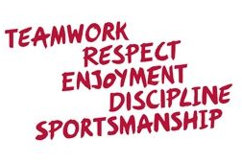
The club rightly puts a great deal of emphasis on the safeguarding of the children and takes the matter very seriously.
Our Club Safeguarding Officer (CSO) Karl Roberts works hard right across the club to ensure that everyone knows their responsibilities.
Any breach of the guidelines below will be appropriately challenged as soon as they are highlighted. All breaches will be reported to the committee and the RFU.
Should you, as a parent, become aware of any concerns, please do notify the CSO safeguarding@maidenheadrfc.co.uk and your Age Group Manager.
Our Safeguarding & related policies can be found below
Safeguarding & Club Wide Policies

Coaches and age group managers (and other volunteers)
Our volunteer coaches and age group managers are the lifeblood of the club. Without their time, energy and commitment we would not be able to operate such a successful set of age groups and teams. In common with many roles that are responsible for providing a safe place for children they have.

A Duty of Care – Comprehensive training for all coaches and AGE GROUP managers.
All coaches AGM;s and volunteers go through a number of checks and onboarding before they can participate in regulated activity, which coaching falls into:

- A Volunteer application form completed for all new to club volunteers.

- Disclosure and Barring Service (DBS) checks - All coaches, AGM’s and volunteers must complete a DBS check.

The process is straight forward; Complete mandated e-learning modules via your GMS profile. Use course finder and purchase Intro to safeguarding along with Headcase. They have to be bought (both free) and the checkout process completed. You then complete each course by clicking on the link in the emails sent to you by the RFU following purchase. Once both courses show a green tick on your GMS profile arrange a meeting with the CSO for a Document verification meeting.
Document verification meeting
2 forms of Photo ID are required - Passport and Driving licence.
A proof of Address is also required and these are strictly limited.
This years Council tax bill or a pension statement either dated within the last 12 months Or
Bank statement - posted by the institution to your home address and dated within the last three months Or
Utility Bill - posted by the institution to your home address and dated within the last three months
The submission process can take a few weeks to be processed so early submission of the above is necessary to ensure the club, RFU and Regulation 21 are complied with.

DBSs are valid for 3 years and then need to be renewed.

- All key volunteers are kindly asked by the club to also complete the Play it Safe (PiS) course which is further RFU delivered and more training in safeguarding. Please talk to your AGM if you want to find out more.
Other training courses, when relevant, are deployed to the coaching/volunteer community as directed by the committee and CSO.

Parents
- Your child’s safety and wellbeing is paramount.
- It is the Club’s policy that either a parent or an assigned guardian is present pitch side at all training, fixtures and tournaments for all U18s players.
- It is up to every parent to arrange ‘cover’ if you cannot be present and ensure another guardian is present and the Age Group Manager/coaches are made aware of who that is.
- Please alert your Age Group Manager to any safe guarding issues.
- Please ensure that any medical conditions are added to GMS and that your Age Group Manager is made aware aswell.

First Aid

MRFC is committed to provide all age groups with adequately trained first aiders so you will find a number of coaches and parents will be volunteer first-aiders.

Any parents that hold a first aid qualification or who would like to be considered for the club’s first aid course should make themselves known to the manager and/or head coaches.

A first aid kit will be available at every training session via your age groups 1st aiders.

Discipline
Current Code of Conduct for Youth Players

As a member of Maidenhead RFC you are expected to abide by the following youth code of conduct:

- All members must play within the rules and respect officials and their decisions.
- All members must respect the rights, dignity and worth of all participants regardless of gender, ability, cultural background or religion.
- Members should keep to agreed timings for training and competitions or inform their coach or team manager if they are going to be late.
- Members must wear suitable kit for training and match sessions, as agreed with the coach/team manager: gum shields are compulsory as well as the correct IRB approved studs in boots. Make sure that kit is suitable for the weather conditions and it is recommended that all members bring a water bottle.
- New members to the club must pay the club subscription after 3 weeks of attendance for training.
- Play with discipline
- Junior members are not allowed to consume alcohol or drugs of any kind on the club premises or whilst representing the club whether at Braywick or at any away venue.
- Respect the club’s equipment, facilities and staff members and always behave in a suitable manner when enjoying the club bar and general facilities.
- Members must remember that they are representing the club at all times and must not act, dress, or behave in public in a manner that may be detrimental to or bring into disrepute the interests, welfare or image of Maidenhead RFC.
- Members shall not at any time make comment for publication, by any media including social media, regarding Club matters or policies that may bring the club into disrepute, or regarding the performance of a referee, assistant referee, or any other official.
- Maidenhead RFC cannot, and will not, condone acts of verbal abuse or violence under any circumstances.

Code of Conduct for Parents / Carers / Guardians
- Encourage your child to learn the rules and play within them.
- Discourage unfair play and arguing with officials.
- Help your child to recognise good performance, not just results.
- Never force your child to take part in sport.
- Set a good example by recognising fair play and applauding good performances of all.
- Never punish or belittle a child for losing or making mistakes.
- Publicly accept officials' judgements.
- Support your child's involvement and help them to enjoy their sport.
- Use correct and proper language at all times whether at Maidenhead or visiting local clubs..
- Encourage and guide participants to accept responsibility for their own performance and behaviour.
- Respect the club’s equipment, facilities and staff members and always behave in a suitable manner when enjoying the club bar and general facilities.
- Members must remember that they are representing the club at all times and must not act, dress, or behave in public in a manner that may be detrimental to or bring into disrepute the interests, welfare or image of Maidenhead RFC.
- Members shall not at any time make comment for publication, by any media including social media, regarding Club matters or policies that may bring the club into disrepute, or regarding the performance of a referee, assistant referee, or any other official.
- Maidenhead RFC cannot, and will not, condone acts of verbal abuse or violence under any circumstances.

Code of Conduct for Coaches, Club Officials And Volunteers

Maidenhead RFC expects all coaches, club officials and volunteers to act in accordance with the good ethical conduct and practice as summarised below:

- Consider the wellbeing and safety of players before the development of performance.
- Develop an appropriate working relationship with players, based on mutual trust and respect.
- Make sure all activities are appropriate to the age, ability and experience of those taking part.
- Promote the positive aspects of the sport (eg fair play).
- Recognise that many officials and referees are volunteers, who devote considerable time to enhancing the enjoyment of rugby union for all – value them and treat them with respect
- Display consistently high standards of behaviour and appearance.
- Follow all guidelines laid down by the national governing body and the club.
- Hold appropriate valid qualifications and insurance cover.
- Never exert undue influence over players to obtain personal benefit or reward.
- Never condone rule violations, rough play or the use of prohibited substances including alcohol to underage players
- Encourage players to value their performances and not just results.
- Encourage and guide players to accept responsibility for their own performance and behaviour.
- Respect the club’s equipment, facilities and staff members and always behave in a suitable manner when enjoying the club bar and general facilities.
- Members must remember that they are representing the club at all times and must not act, dress, or behave in public in a manner that may be detrimental to or bring into disrepute the interests, welfare or image of Maidenhead RFC.
- Members shall not at any time make comment for publication, by any media including social media, regarding Club games, matters or policies that may bring the club into disrepute, or regarding the performance of a referee, assistant referee, or any other official.
- Maidenhead RFC cannot, and will not, condone acts of verbal abuse or violence under any circumstances.

